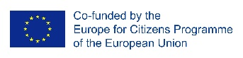
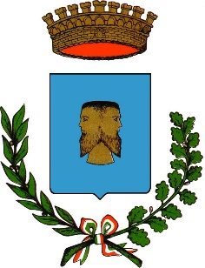
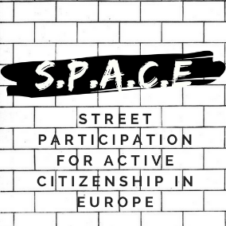

08 April 2018
Press release
SPACE: STREET PARTICIPATION FOR ACTIVE CITIZENSHIP IN EUROPE
THE FIRST EVENT – „KICK-OFF MEETING”
TIGGIANO, ITALY

Strating from the 4th to the 7st of April 2018, Comune di Tiggiano was the host of the first meeting of the „SPACE: Street Participation for Active Citizenship in Europe”, which took place in Tiggiano, Italy, where attended 24 international participants from 10 countries, as well as local citizens. The aim of this meeting was to introduce SPACE project, the main themes, methodology and its objectives.
The official opening started on the 5th of April, where Mr. Morciano (mayor of Tiggiano) and Mr. Evangelista Leuzzi (SPACE Coordinator, IT) welcomed the participants and introduced them the objectives of the SPACE project. The programme continued with the presentation of the project partners and the practices of “Citizens Participation”. Mrs. Lea Sodano from Città Fertile and Mr. Bastien Fillon, the official representative of Officine Cittadine, discussed about two initiatives: “CuntameMo” and “Street Debate”. Thanks to this meeting, the participants had the opportunity to share good practices of citizen’s participation.
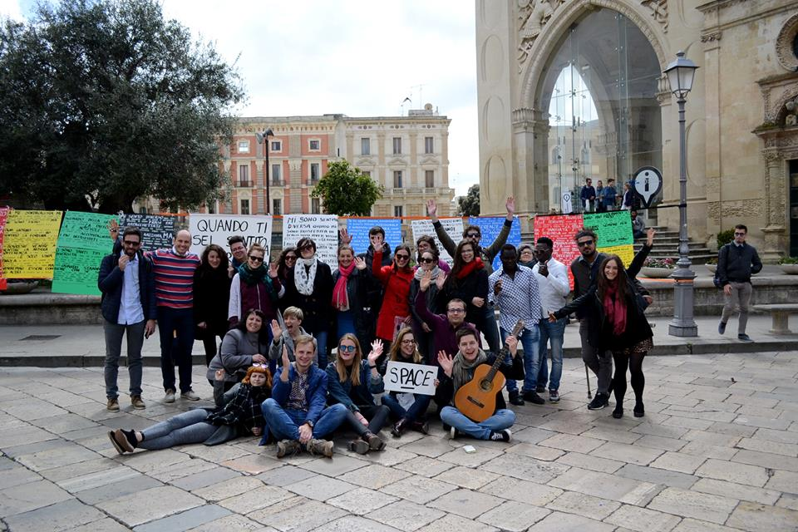
The 6th of April was all about Street Debate. Participants has the chance to experiment the word carrier methodology in the city of Lecce. The topic of the street debate was: „When did you feel different?”. The day ended with a study visit to „Celacanto” and the presentation of the „Gallery of Active Citizenship in Salento”.

For more information on the event please visit: https://www.facebook.com/STREETPARTICIPATION/

