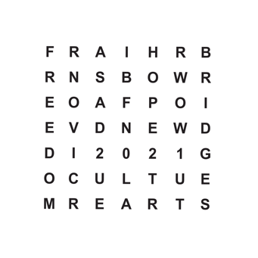
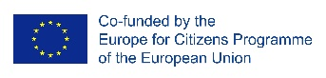
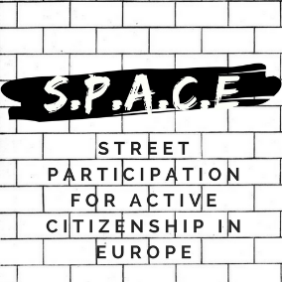

11 May 2019
Press release
SPACE: STREET PARTICIPATION FOR ACTIVE CITIZENSHIP IN EUROPE
THE FIFTH EVENT – „WORKSHOP ON STREET SENSITIZATION”
NOVI SAD, SERBIA

Starting from the 7th to the 10st of May 2019, „Novi Sad 2021” Foundation was the host of the fifth international event of the „SPACE: Street Participation for Active Citizenship in Europe” project. The meeting took place in Novi Sad. The meeting was attended by 26 international participants from 8 countries, as well as local citizens. The meeting focused on the topic of the „Future of Europe”.
The 8th of May started with two workshops. The first one was related to the street debate „the change in Europe”. At the last workshop, participants prepared a joined presentation for the conference of the 9th of May. The day ended with a cultural program „Ode to Joy Challenge”.
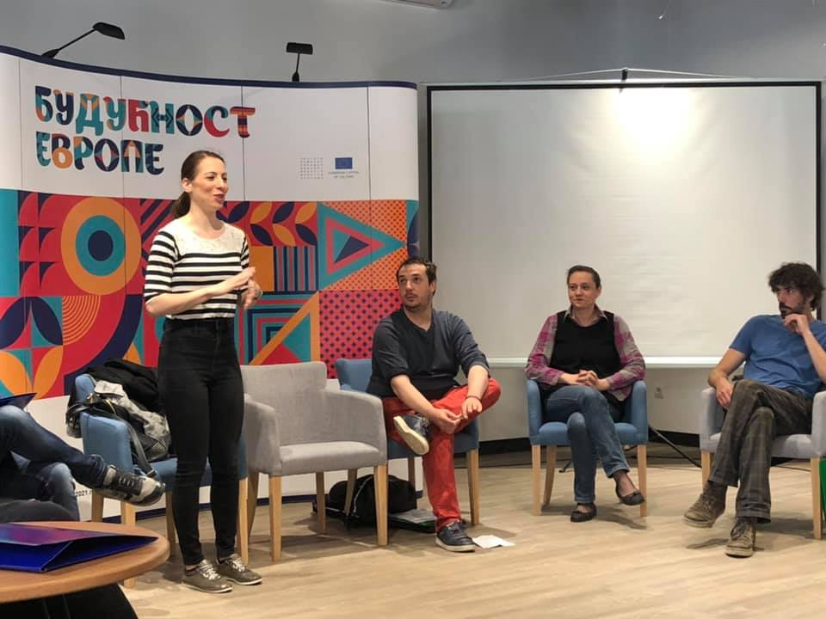
The day of 9th of May „Europe Day” was dedicated to the conference „The Future of Europe”. The participants of SPACE project attended the conference and held some activities, such us: presentation of the „Novi Sad 2021” Foundation, introduction speeches done by Mr. Vuk Radulovic (from „Novi Sad 2021” Foundation) and Mr. Vukasin Grozdanovic (from OPENS 2019-European Youth Capital). The conference continued with Mr. Bastien Fillon presentation about the street debate methodology and guidelines. A public presentation about the results of the SPACE- INTERACTIVE WALK THROUGH EUROPEAN CITIZENS VOICE was done. The conference ended with a public presentation of the „50 ideas for Europe” – OPENS 2019 project and an European Day-celebration concert that took place in Liberty Square.
For more information on the event please visit: https://www.facebook.com/STREETPARTICIPATION/

